CSA1013 – SOFTWARE ENGINEERING
RAPTOR PROGRAMS

- GREATEST OF THREE NUMBERS
AIM: To write a program that reads three numbers from user and identifies the largest number.
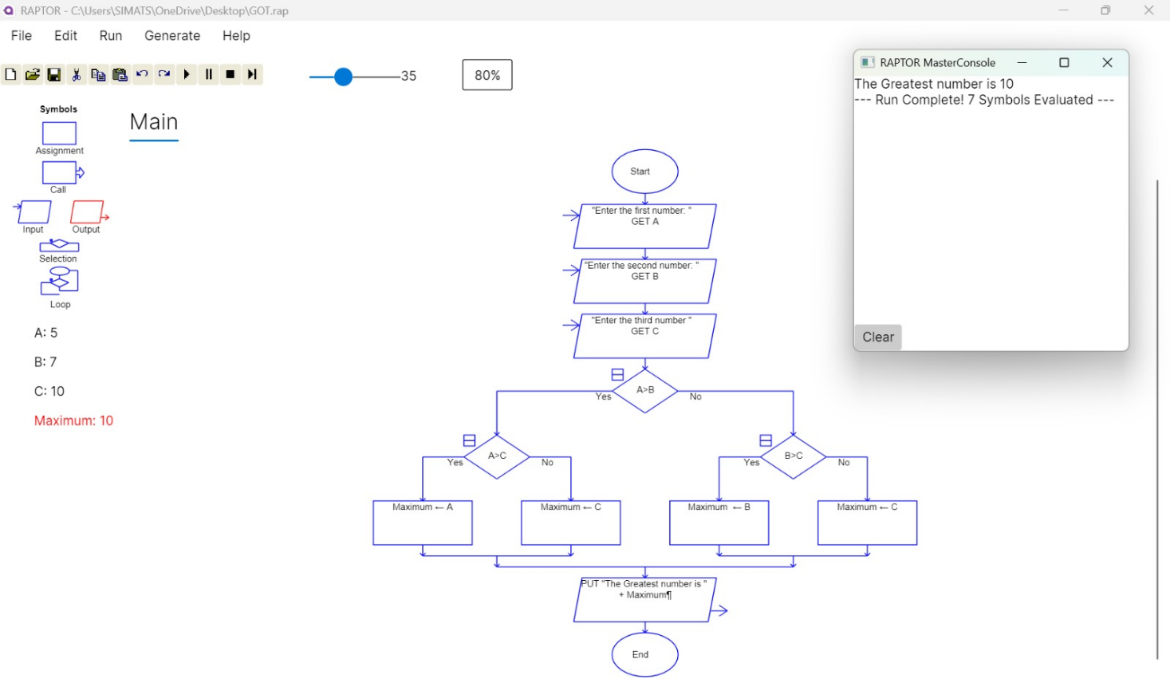

OUTPUT: The program successfully accepted three numeric inputs, compare them and outputted the maximum value.

- ARMSTRONG NUMBER
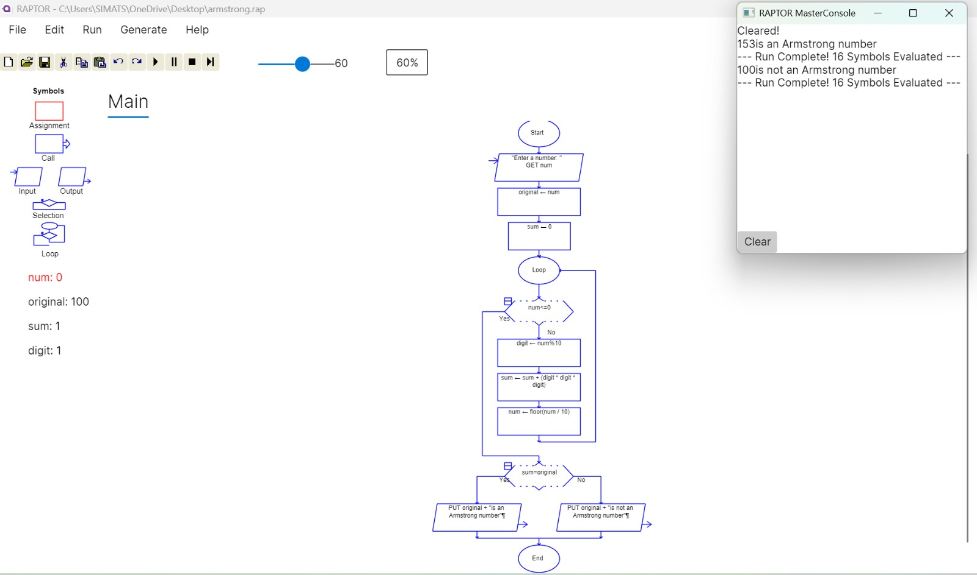
AIM: To write a program that determines provided integer is an Armstrong number or not.

OUTPUT: The program successfully initialized loop and verified the number is Armstrong or not.

- FACTORIAL OF A NUMBER
AIM: To write a program that calculates the factorial of a given positive integer

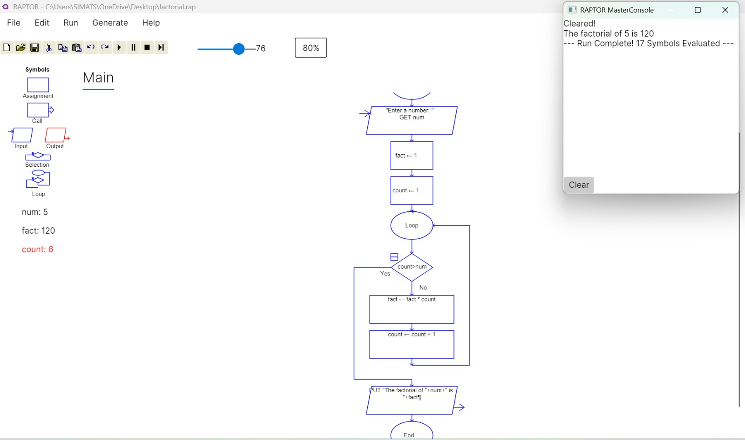

OUTPUT: Thus, the program to calculate the factorial of given number was executed successfully

- NUMBER OF CHARACTERS IN A STRING
AIM: To draw a flowchart that accepts a string from the user, calculates its total length using string handling methods, and displays the character count.

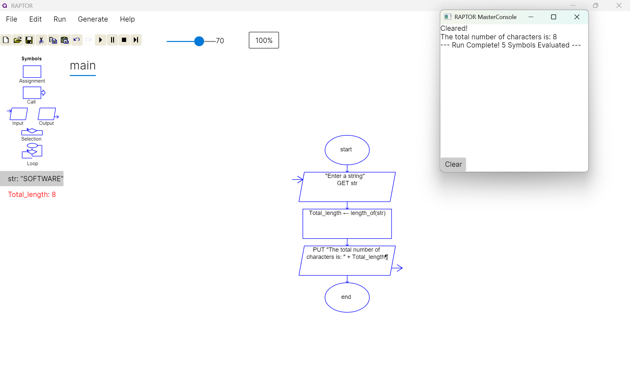

OUTPUT: The program successfully read a string sequence, utilized the built-in length function to count the characters, and accurately outputted the total integer length of the string.

- LEXICOGRAPHICALLY SMALLEST STRING
AIM: To design a flowchart that processes a string of lowercase English alphabets, evaluates all possible single-swap combinations of two distinct characters, and returns the lexicographically smallest resulting string.
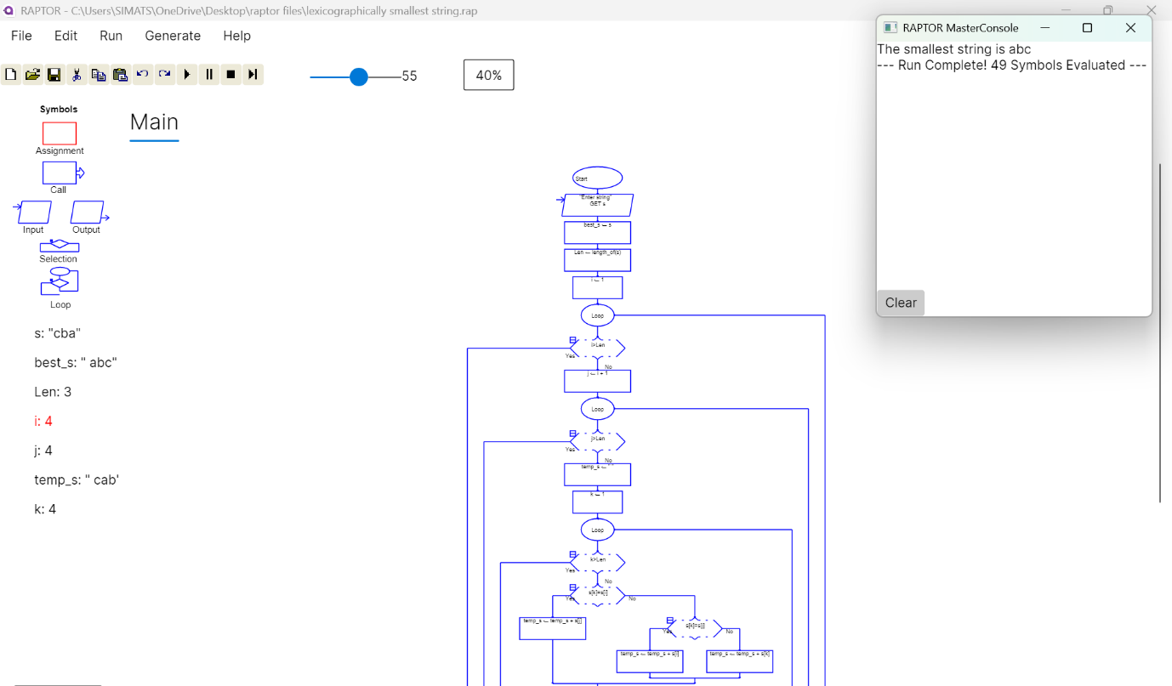

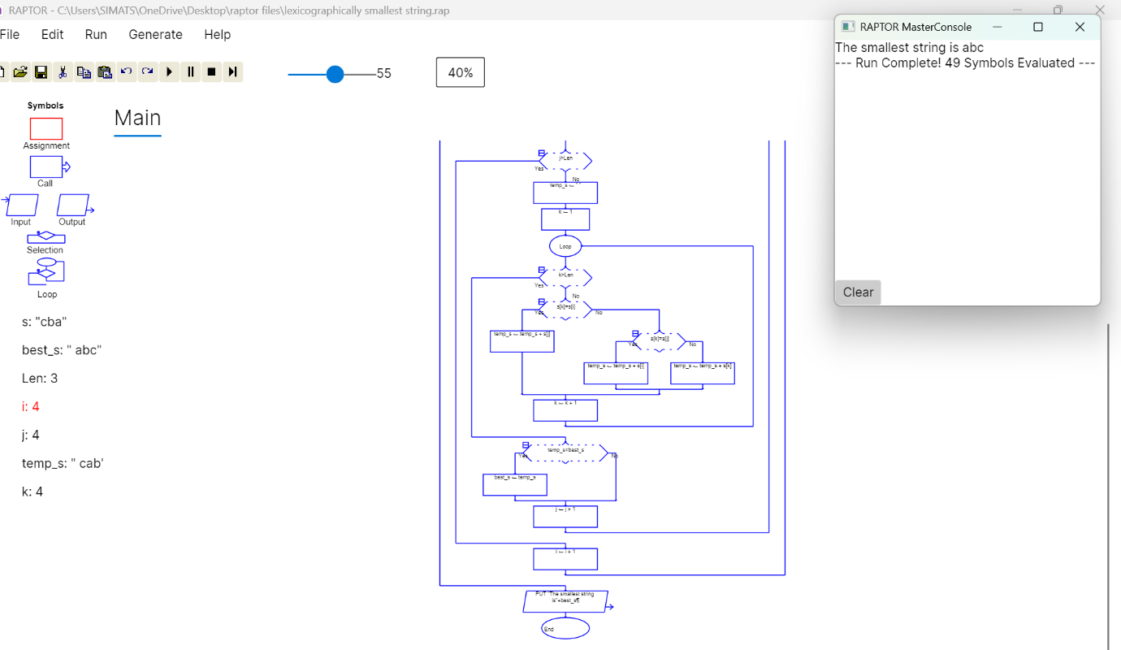

OUTPUT: The program successfully utilized nested loops to traverse the string, simulated replacing all occurrences of character pairs, evaluated them lexicographically, and accurately outputted the smallest possible string configuration.

6.Calculate Cyclomatic Complexity

AIM: To create a flowchart that calculates the Cyclomatic Complexity of a software program's flow graph based on the user-provided number of edges, nodes, and predicate nodes.

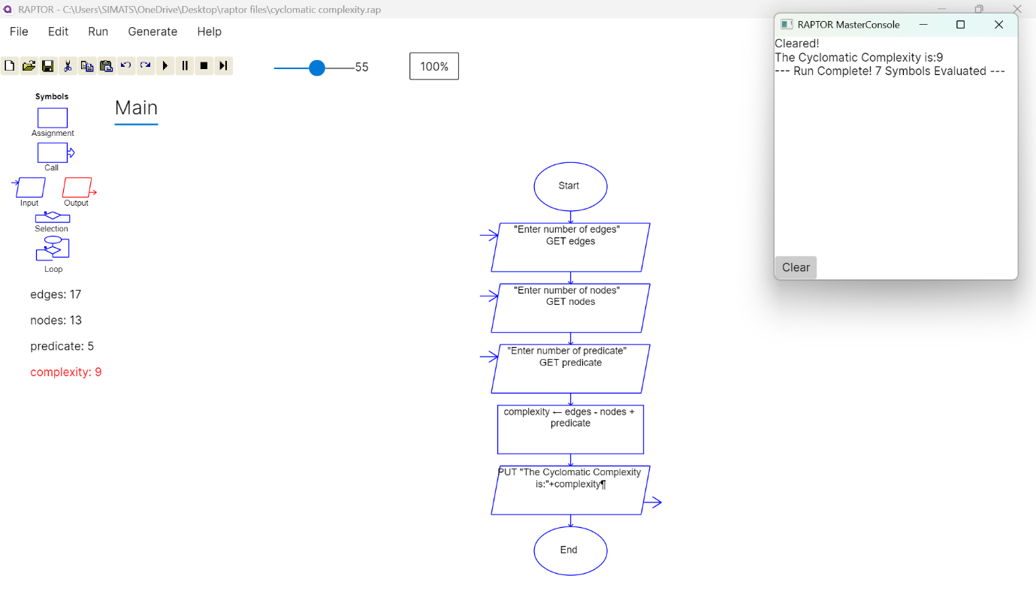

OUTPUT: The program successfully accepted the topological metrics of a flow graph (edges, nodes, and predicate nodes) and correctly computed the Cyclomatic Complexity using the defined arithmetic formula.

